Exp no: 4

Customized Ping Command to Test the Server Connectivity

AIM:
To write a Python program that implements a customized ping command to test the connectivity between a client and a server.

INTRODUCTION:
The ping command is a network utility used to test the reachability of a host on an Internet Protocol (IP) network.
It works by sending ICMP (Internet Control Message Protocol) echo request packets to the target host and waiting for echo replies.
In this experiment, a customized ping command is implemented using Python’s socket and time modules to check if a remote server is reachable.
The program also measures the round-trip time (RTT) to estimate network latency and connection stability.

ALGORITHM:
- Start the program.
- Import the required modules (socket, time, and optionally os).
- Define the server’s hostname or IP address.
- Create a socket using socket.socket(AF_INET, SOCK_STREAM) or use ICMP-based ping via system command.
- Record the start time using time.time().
- Attempt to connect to the server on a specific port (e.g., port 80).
- If the connection is successful,
  - Print “Server is reachable”.
  - Calculate round-trip time (RTT) = (end time – start time).
- If the connection fails,
  - Print “Server is unreachable”.
- Close the socket connection.
- Stop the program.

CODE:
import socket, time
host = "google.com"
port = 80
count = 4
times = []

for i in range(count):
try:
s = socket.socket()
start = time.time()
s.connect((host, port))
end = time.time()
s.close()
rtt = (end - start) * 1000
times.append(rtt)
print(f"Reply from {host}: time={rtt:.2f} ms")
except:
print("Request timed out")

if times:
print("\nMin RTT =", min(times), "ms")
print("Max RTT =", max(times), "ms")
print("Avg RTT =", sum(times)/len(times), "ms")

Output (status):
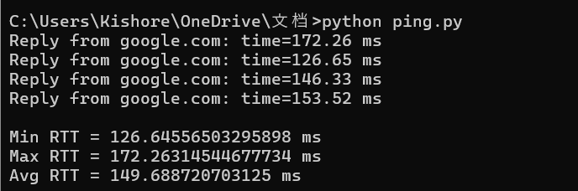

RESULT:The customized ping command was successfully implemented using Python.
The program accurately tested server connectivity and displayed whether the server was reachable along with the response time (RTT).

